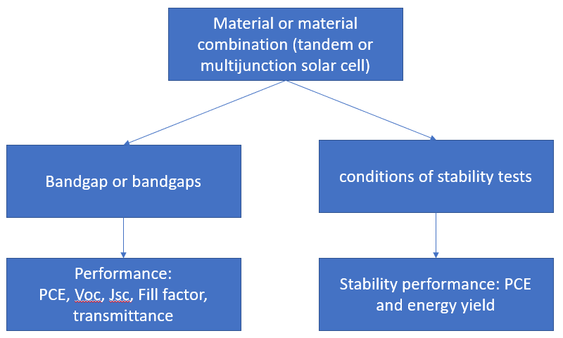

A -> B

* What is bandgap of Absorber/ Absorber blend/ Absorber material/ Inorganic absorber material/ Absorber perovskite/ Active material/ Dye sensitizer/ Sensitizing dye/ Luminophore and absorber material of solar cell with luminescent concentrator -> Bandgap [eV]

A + B -> C

* What will be solar cell performance using Material with Bandgap

(Material relates to Absorber/ Absorber blend/ Absorber material/ Inorganic absorber material/ Absorber perovskite/ Active material/ Dye sensitizer/ Sensitizing dye/ Luminophore and absorber material of solar cell with luminescent concentrator

solar cell performance relates to PCE [%], initial PCE [%], average visible transmittance [%], fill factor [%], Jsc [mA cm-2], Voc [mV])

* What will be tandem solar cell performance using Top absorber material of tandem solar cell/ Top absorber of tandem solar cell with Top material bandgap of tandem solar cell [eV] and Bottom active absorber material/ Bottom absorber material with Bottom material bandgap [eV]/ Bottom absorber material bandgap [eV]
* What will be multijunction solar cell performance using middle and top absorber material of multijunction solar cell/ middle and top absorber of multijunction solar cell with middle and top material bandgap of multijunction solar cell [eV] and Bottom active absorber material/ Bottom absorber material with Bottom material bandgap [eV]/ Bottom absorber material bandgap [eV]
* What will be solar cell PCE using Material(s) after 100/200/1000 h test in conditions of stability tests
* What will be solar cell Energy yield using Material(s) in 200/1000 h test in conditions of stability tests

(Material(s) relates to Absorber/ Absorber blend/ Absorber material/ Inorganic absorber material/ Absorber perovskite/ Active material/ Dye sensitizer/ Sensitizing dye/ Luminophore and absorber material of solar cell with luminescent concentrator

Or Top absorber material of tandem solar cell/ Top absorber of tandem solar cell and Bottom active absorber material/ Bottom absorber material

Or middle and top absorber material of multijunction solar cell/ middle and top absorber of multijunction solar cell and Bottom active absorber material/ Bottom absorber material

)

Unable to answer

* What will be tandem solar cell performance using Top absorber material of tandem solar cell/ Top absorber of tandem solar cell with Top material bandgap of tandem solar cell [eV]
* What will be solar cell PCE using Material(s) after 100/200/1000 h test